**CSC320 A1 Report**

Jiale Duan

1002065775

Device: IPhone 6 plus camera 4.15mm f/2.2

Setting: Flash light off; HDR off

Exposure: Auto, 1/15 sec, ISO125

Time: Noon, around 1 PM

Efficiency of my triangulation matting algorithm:

Let row = compA.shape[0] column = compA.shape[1]

If I used double for loop to operate on RGB values of every pixel one by one, the speed will be very slow because there are row * column iteration being performed, plus matrix operations for each iteration. Hence, it will be faster and more efficient if I implemented my algorithm with numpy matrix operations directly. Everything worked fine such as finding 4d Cdelta matrix and 4d coefficient matrix. I ran into some difficulties when I tried to find the pseudo inverse of my big 4d coefficient matrix because the numpy.linalg.pinv method is not broadcasting to my 4d matrix. This method only works on 2d m by n matrix. Fortunately, numpy.linalg.svd is abled to broadcast to nd matrix. Hence, I implemented my own pinv method with singular value decomposition to find pseudo inverse of 4d matrix without any loop. This way, I am able to implement my matting algorithm a lot faster than the for-loop version.

Background:

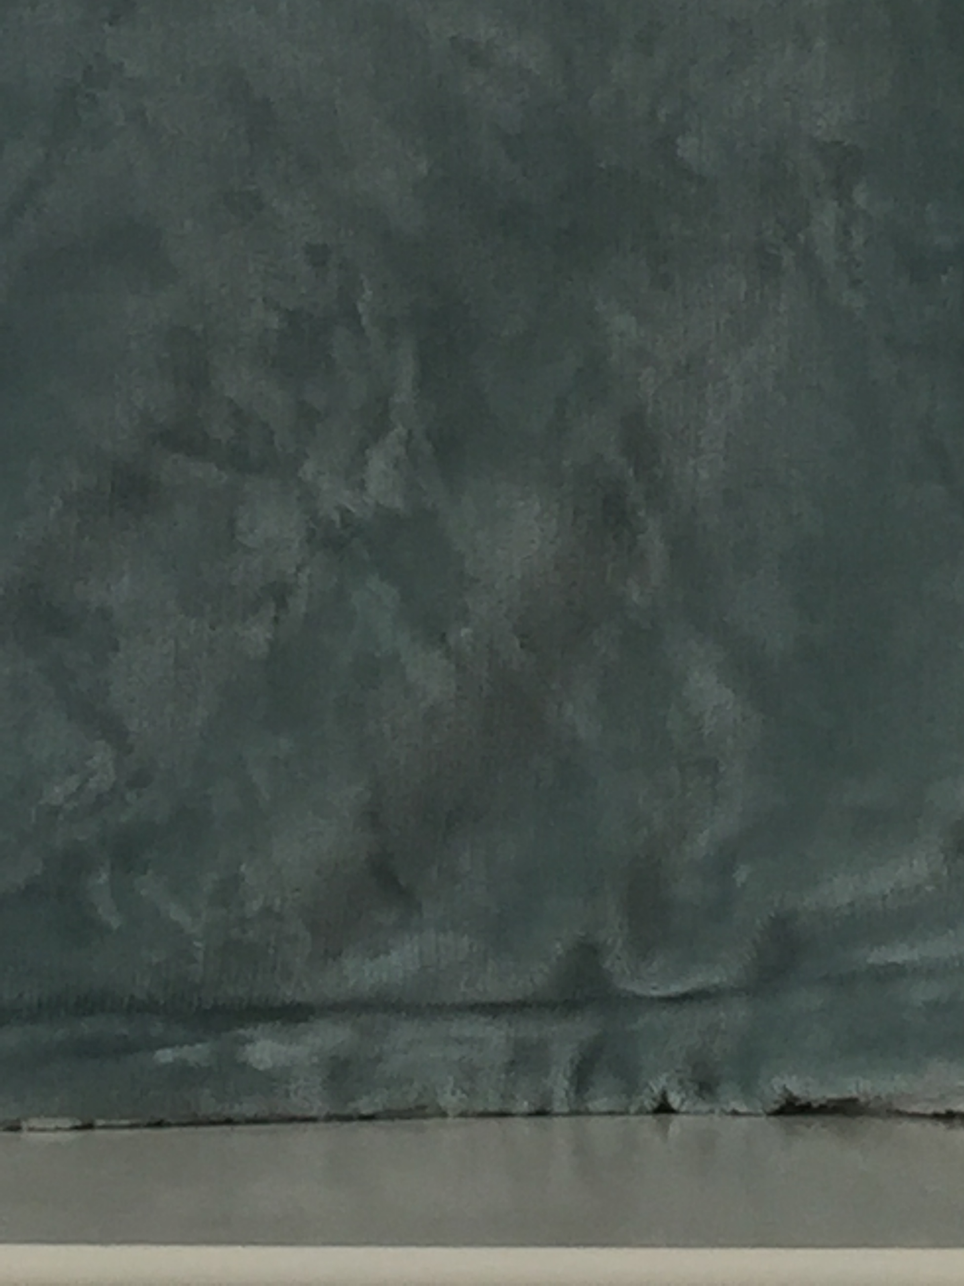

back_a (light green)

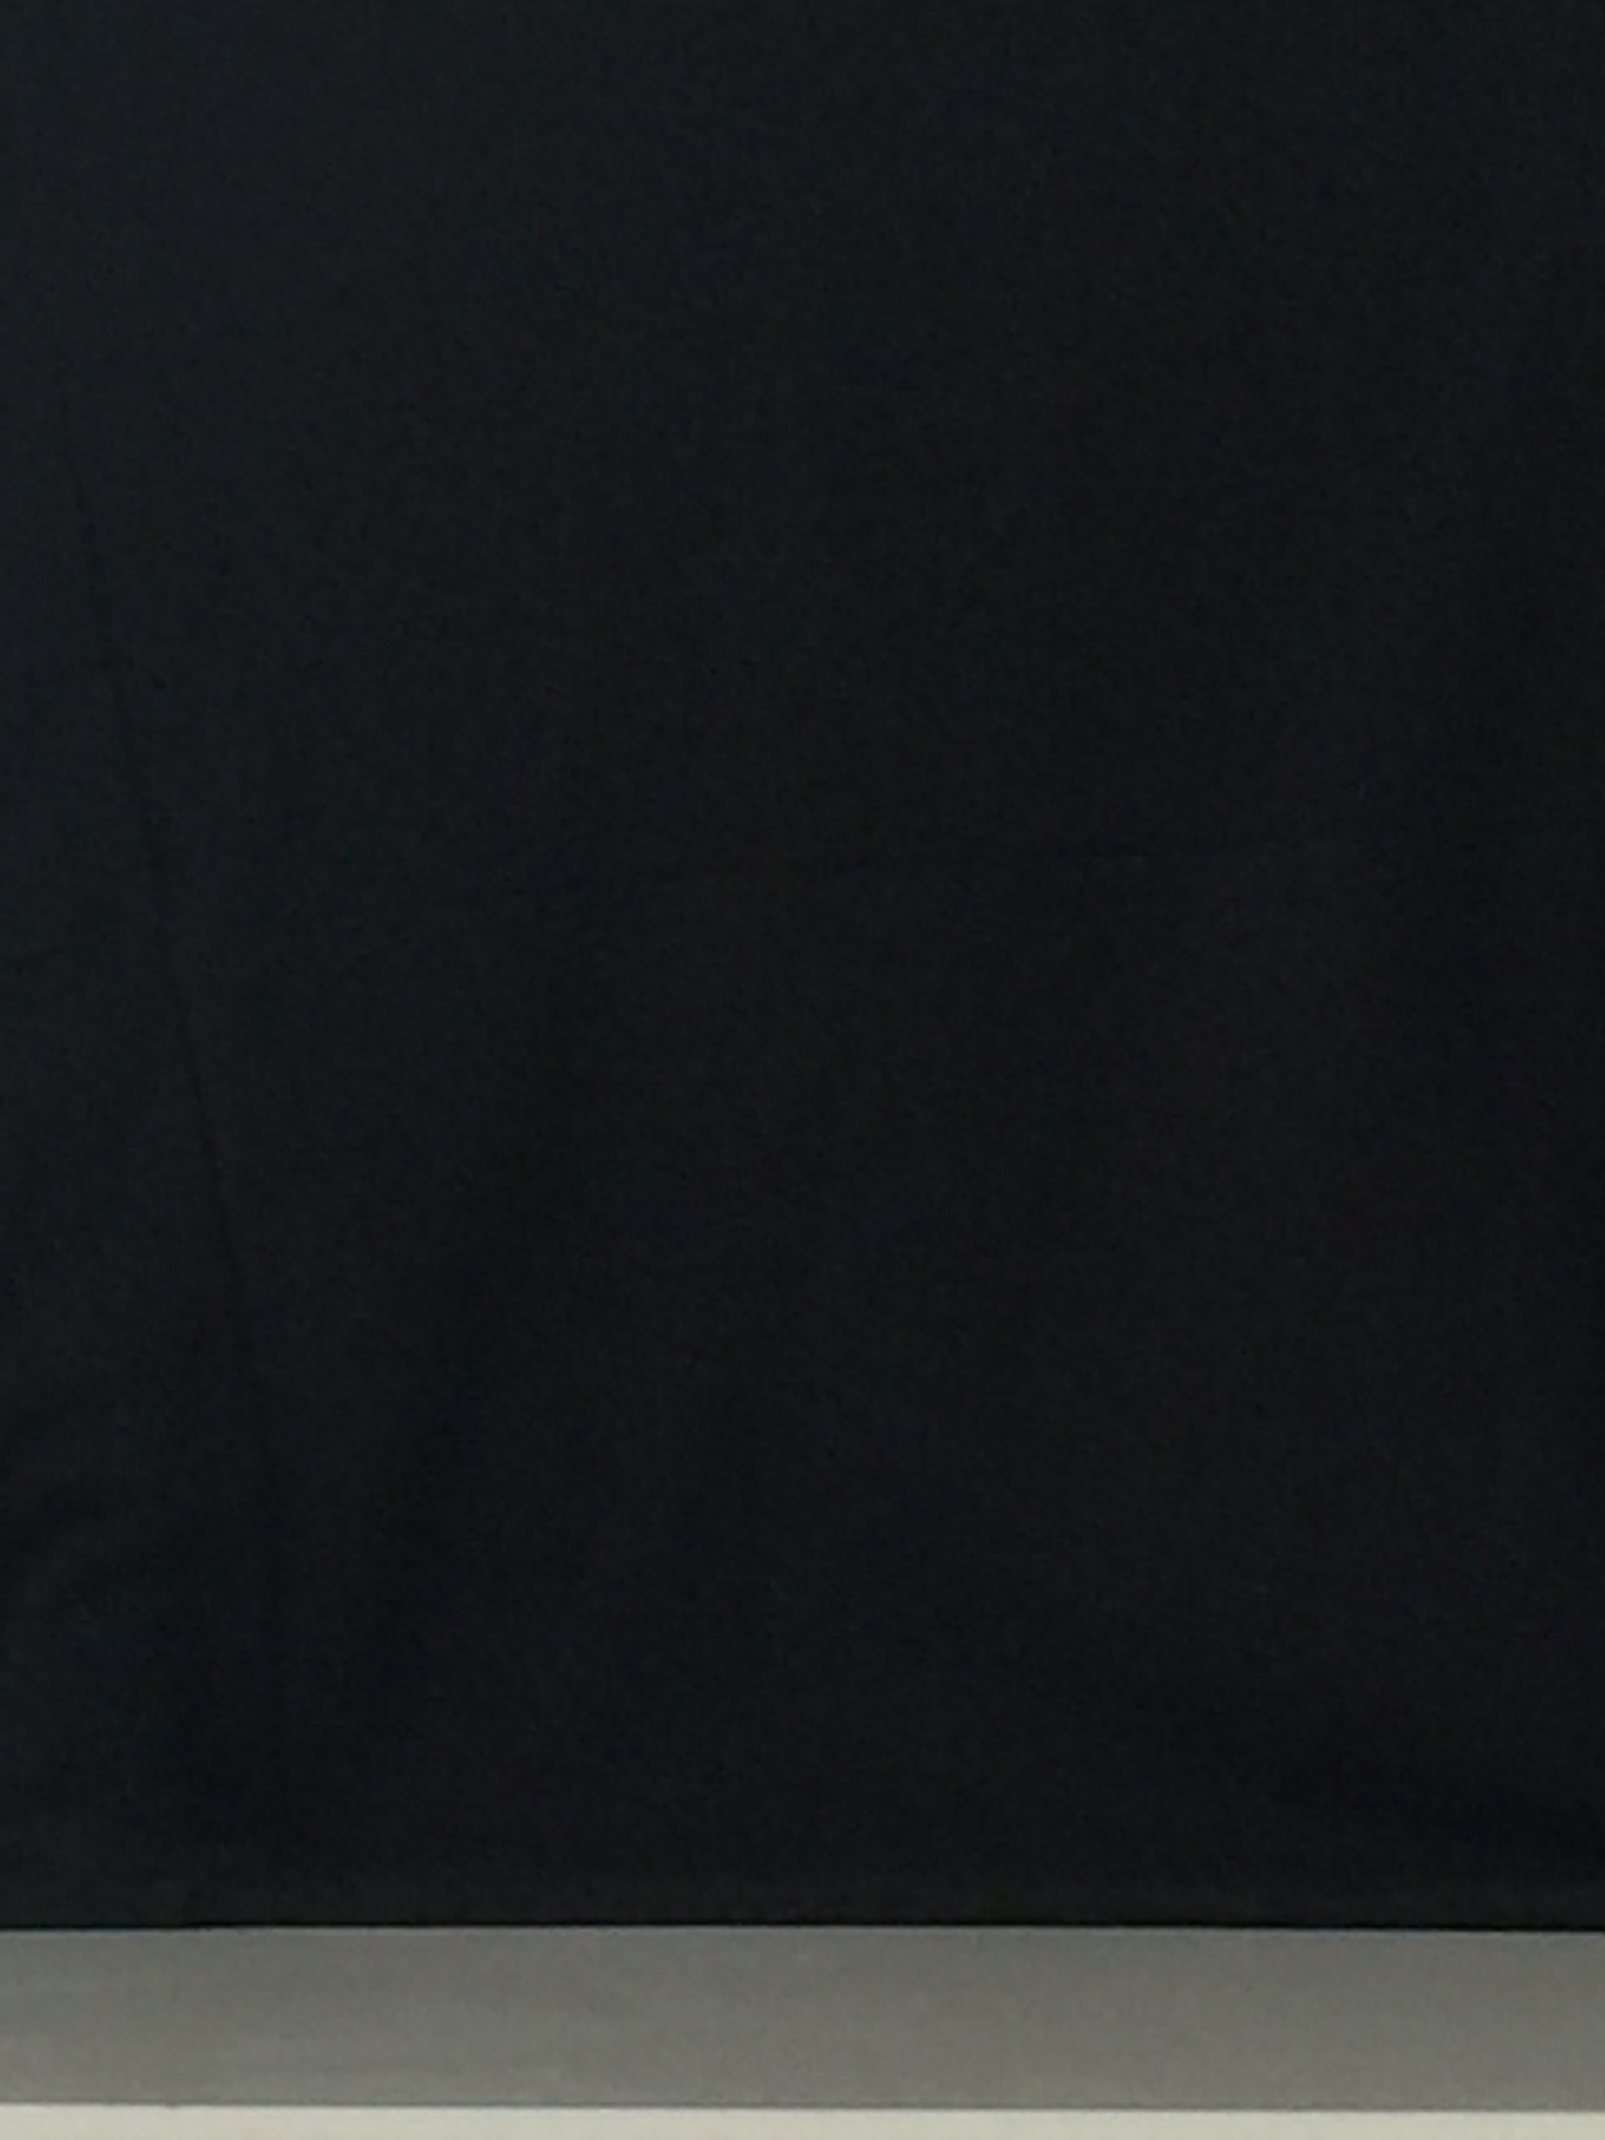

back_a (black)

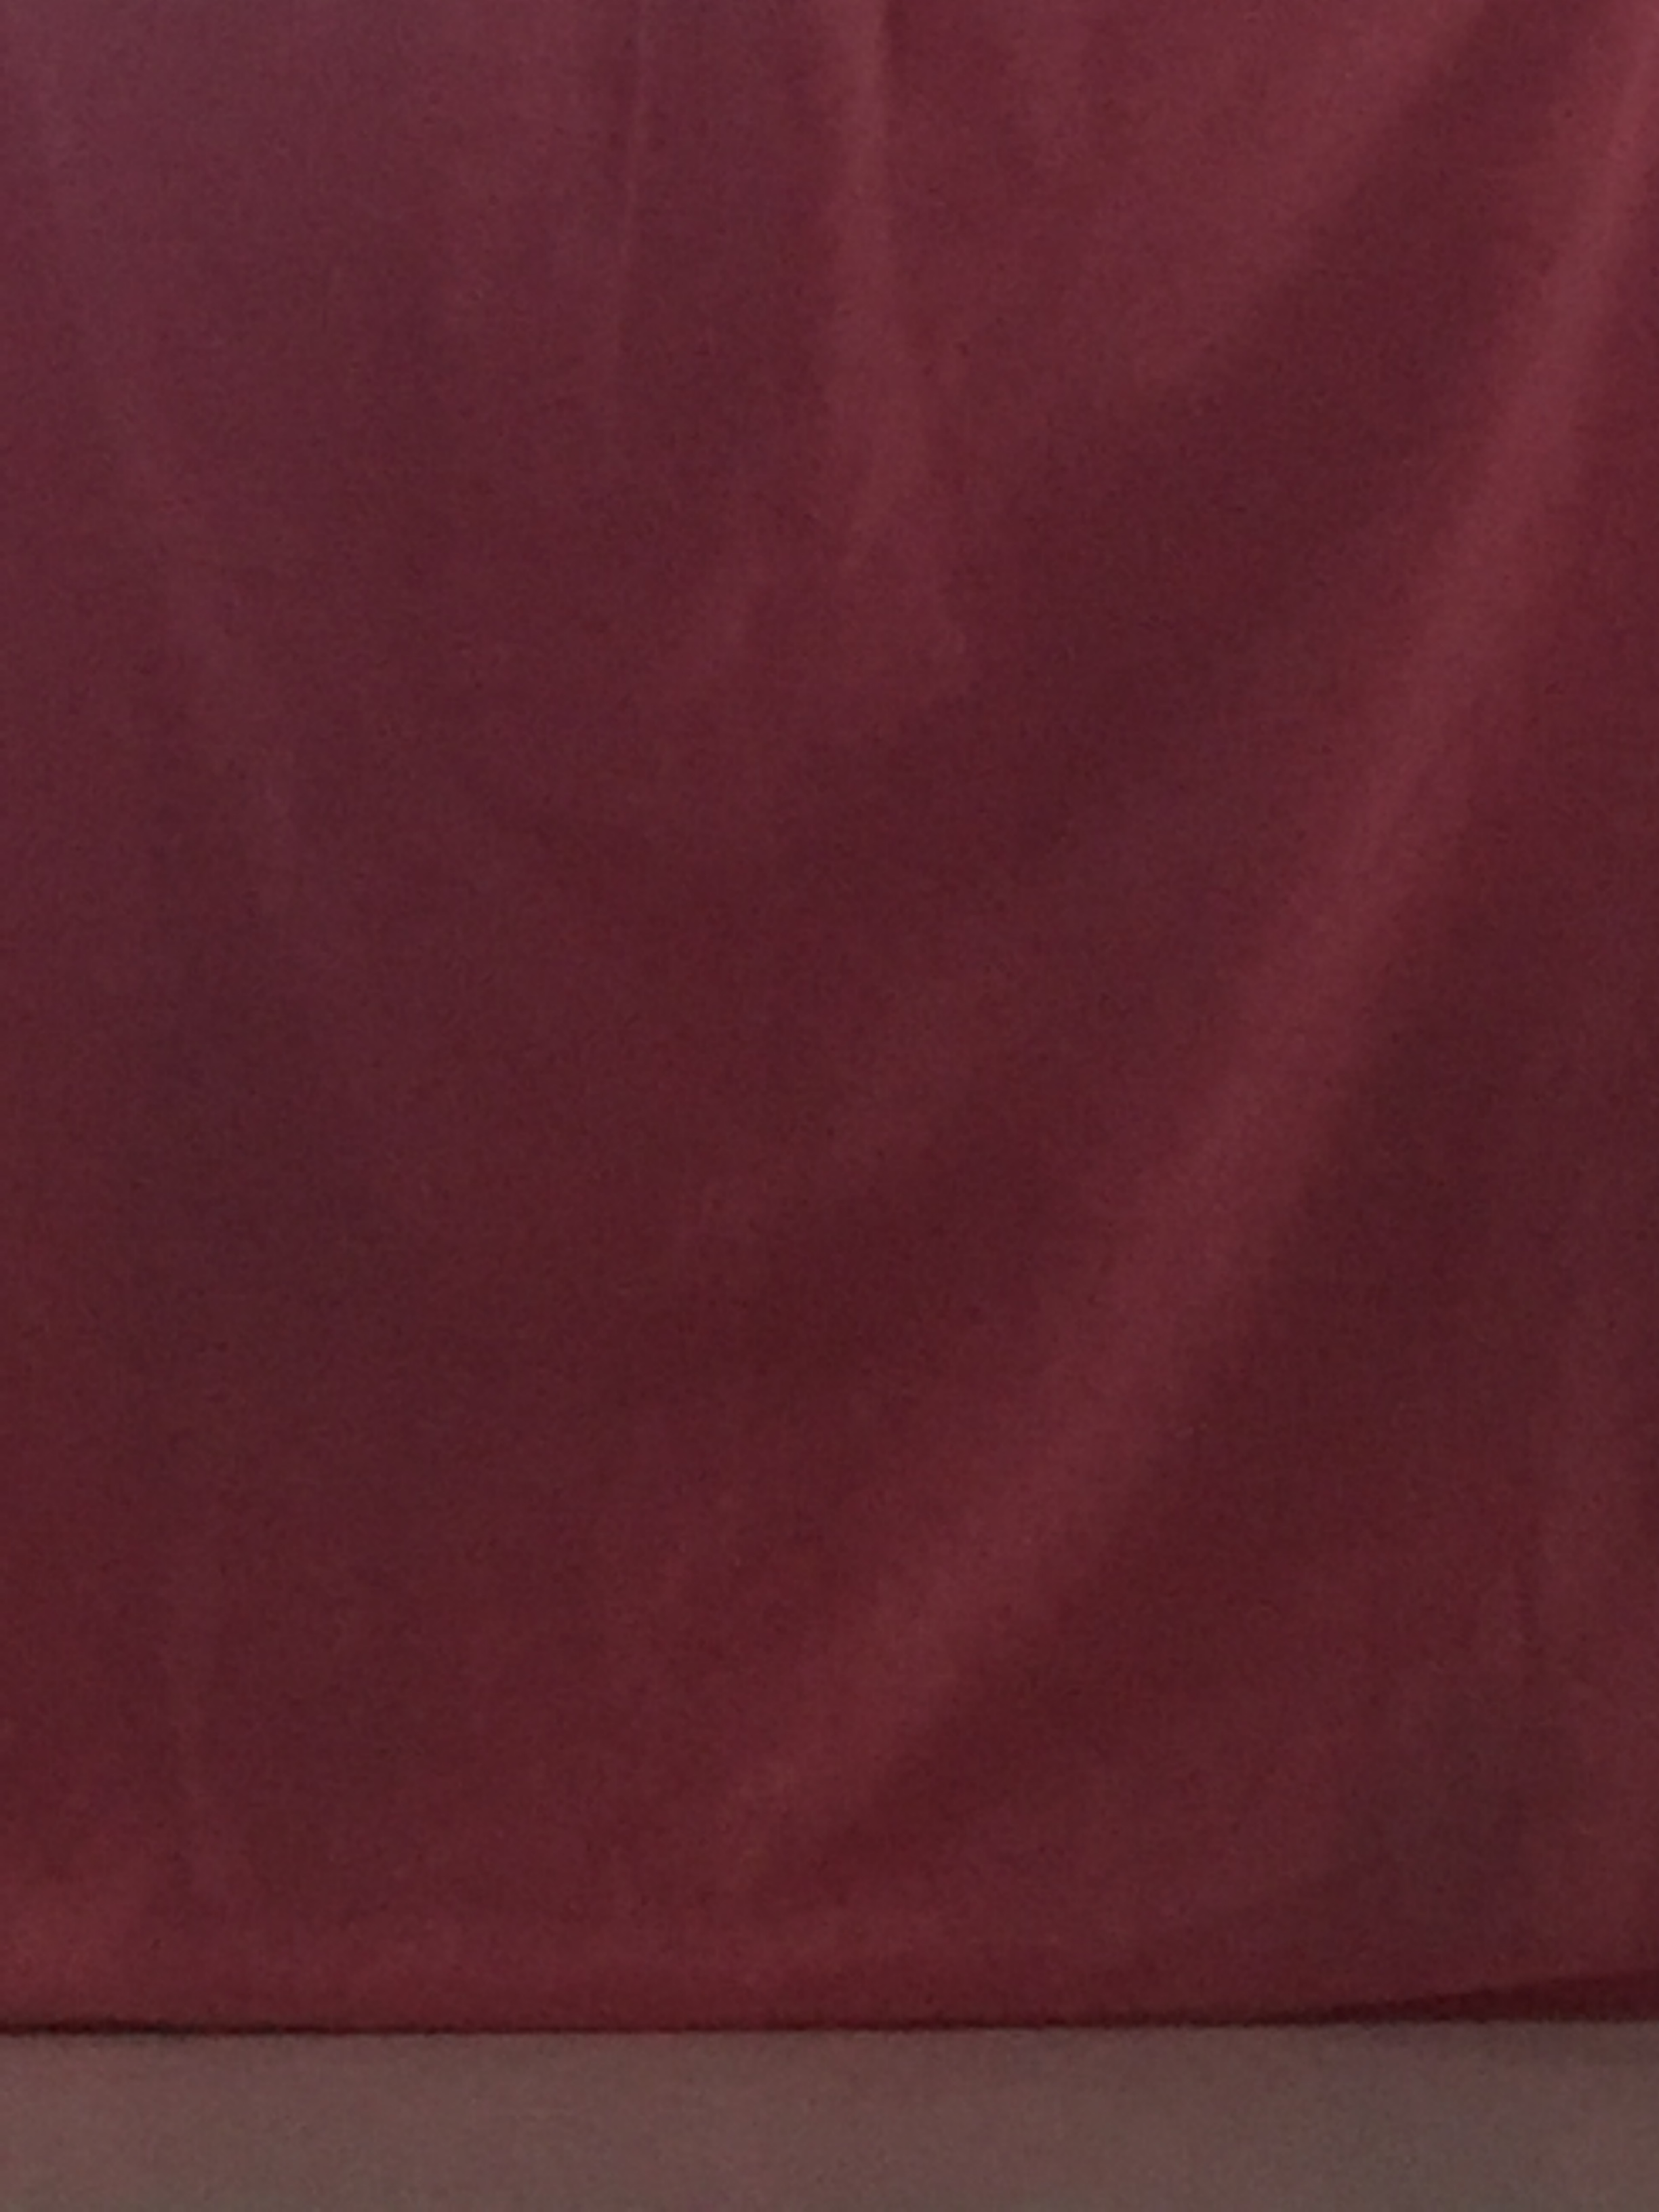

Optional background (pink)

Objects:

Lucky cat (China)

Bottle water

Cristal

Toy (with similar color with background)

ET toy

Procedure:

I put my foreground objects on a chair near the window with curtain shut off. Then found a right position in front of this chair, used a box to make my phone stand right there, and not moved any more. After all these had been done, placed each objects on the chair one by one, also switched background to get all images I want.

Problem:

However, I did not notice there was a gap near the bottom of window curtain. The light source did not evenly distribute over the objects I took. When I did triangulation matting on those images, the bottom part was not successful.

e.g:



compA.jpg



compA.jpg



color.tif



alpha.tif

Another problem of my experiment was the background color I chose were similar under weak light source. Hence, the matting was failed because light source was not strong enough to distinguish them on my phone.

e.g:

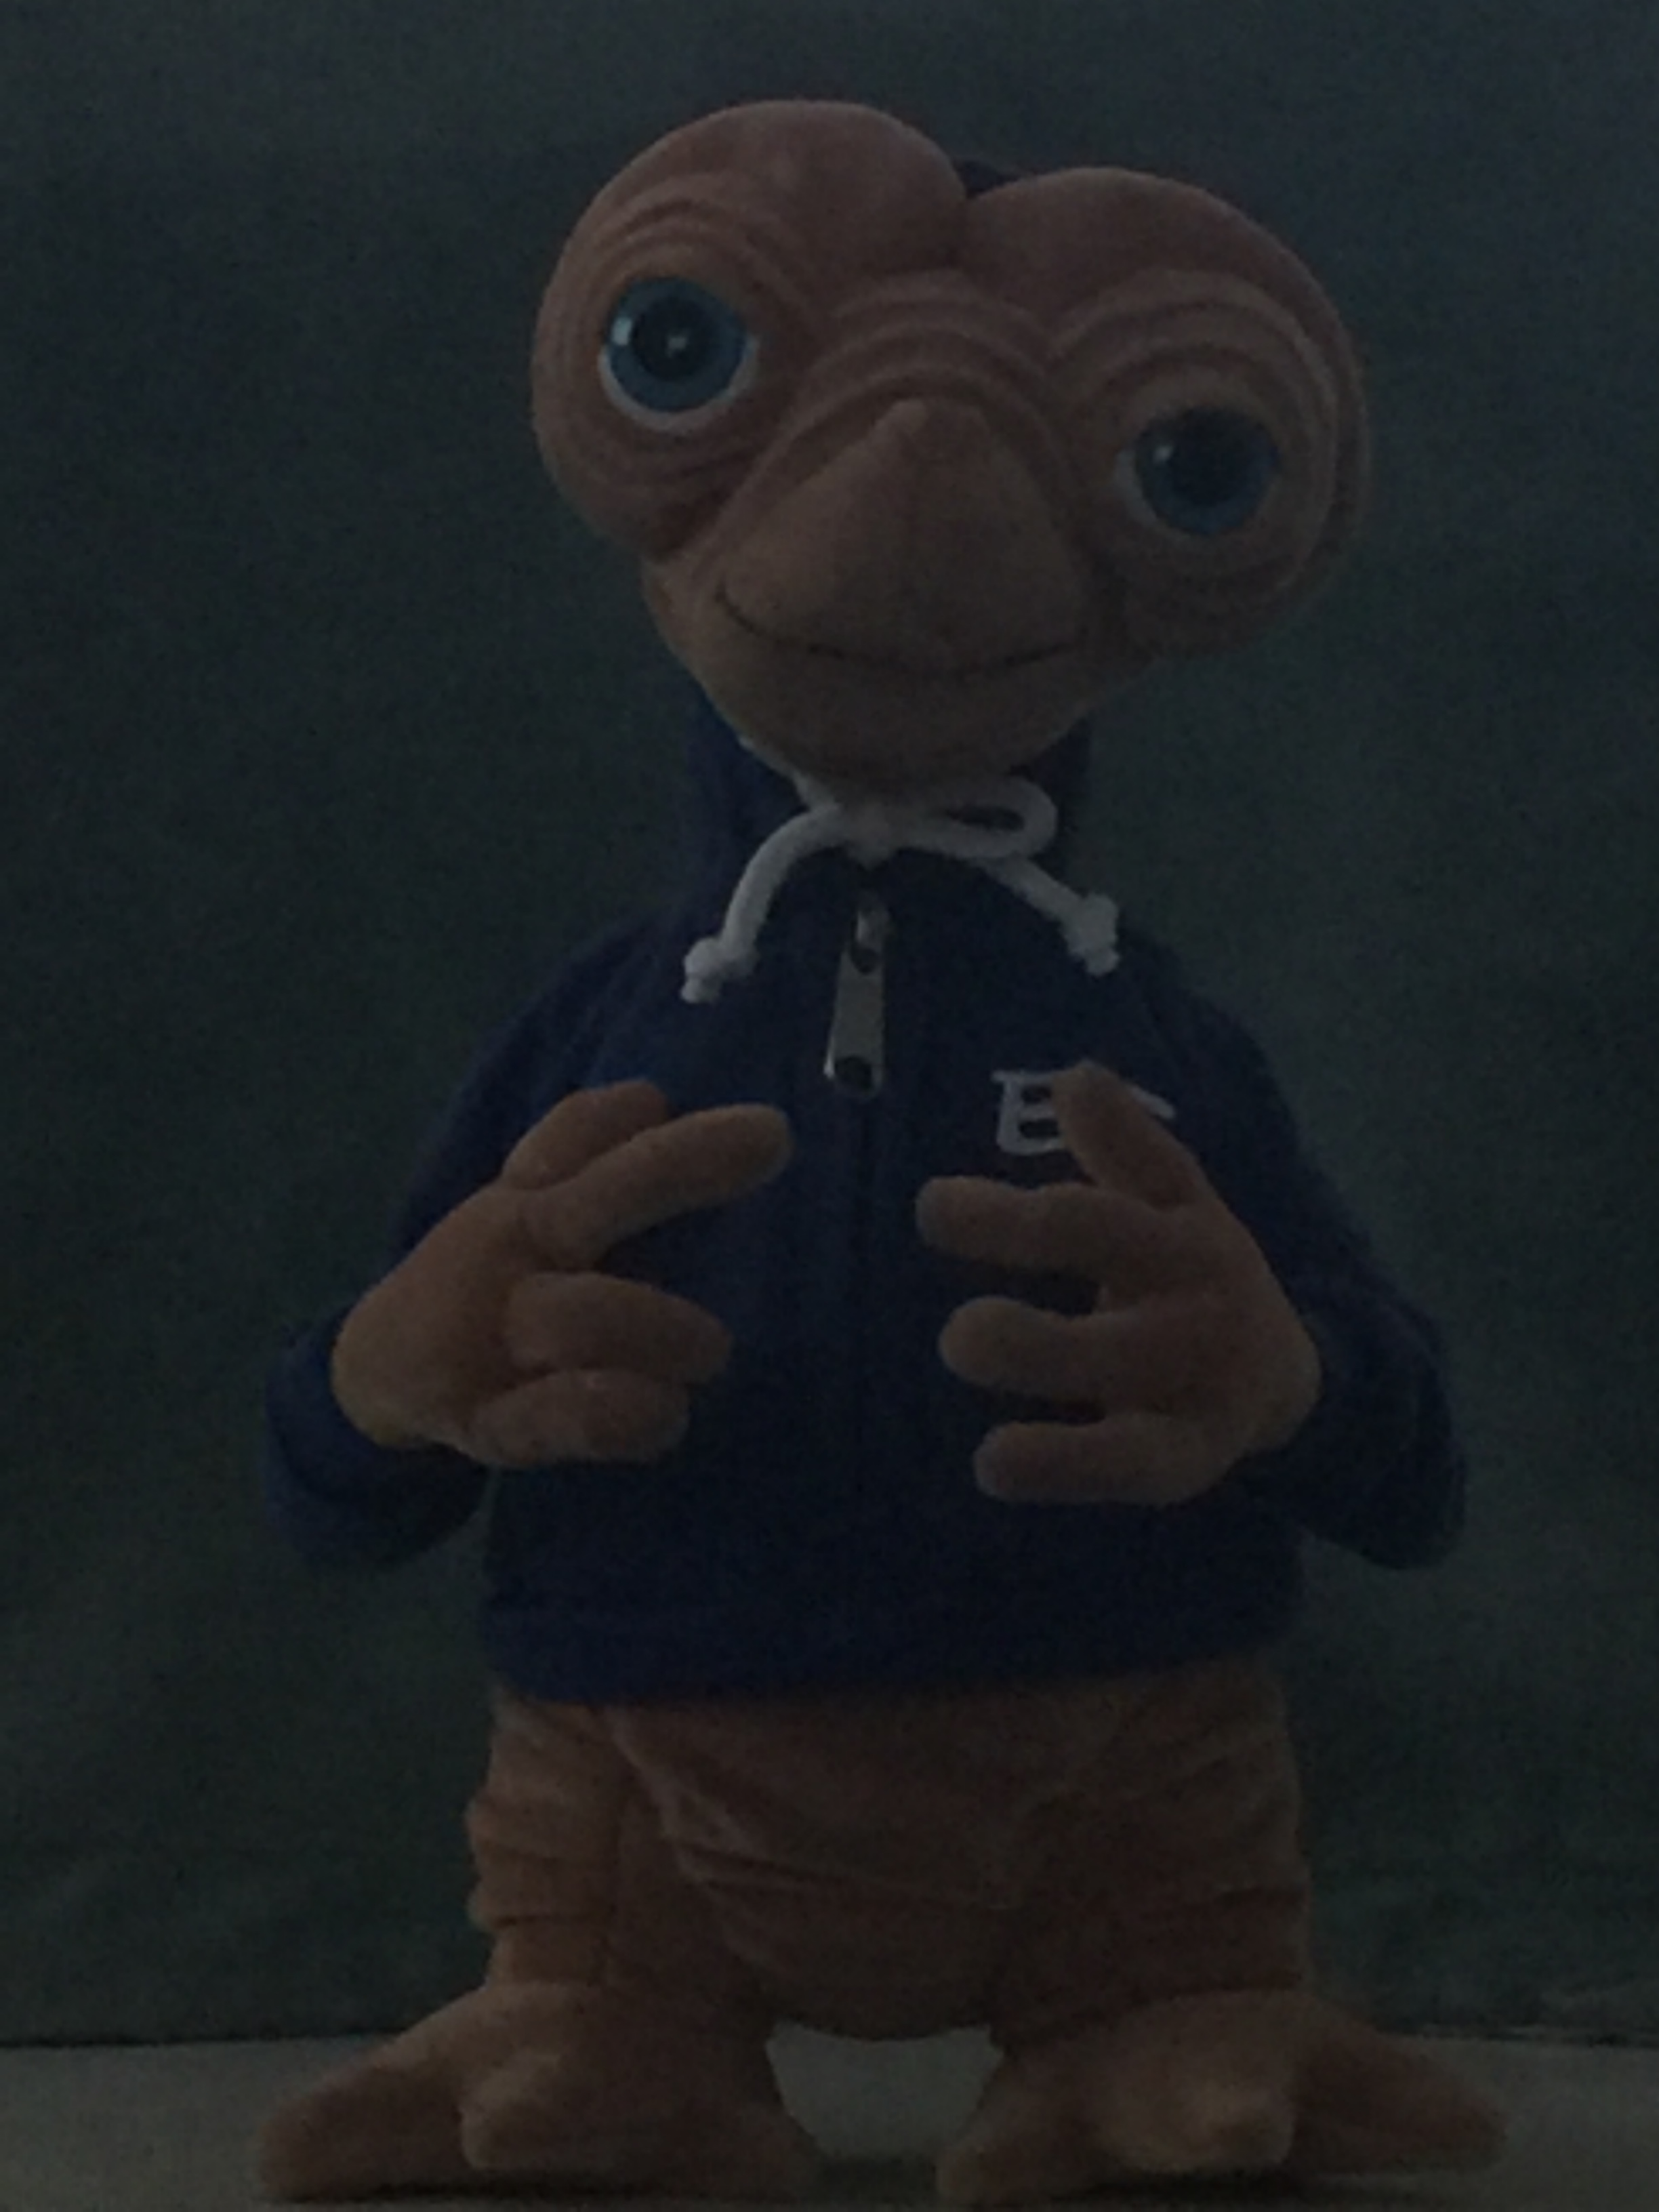

compA.jpg

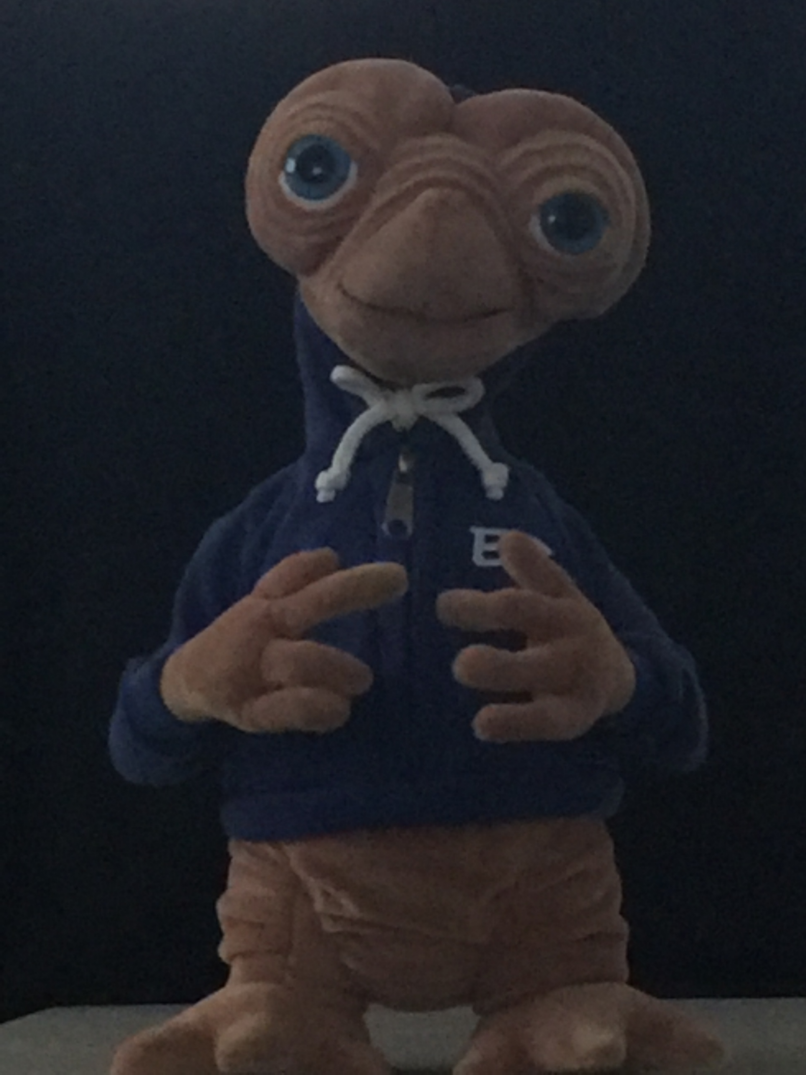

compB.jpg



color.tif



alpha.tif

Because the RGB values of two composite images and two background images are quite similar, from the matting equation, the alpha value then will equal to one. Hence, my alpha.tif is all white. As a result, the matting image will be the same as composite image. We can check from the above example.

Conclusion:

To be concluded with my experiments, even though triangulation matting is quite easy to implement, there are a few limitations of condition when we prepare photos.

* Light source: light source need to be perfect and evenly distributed to the foreground. It cannot be too strong or too weak. The light source at least needs to be strong enough to distinguish different background colors on camera.
* Background color: background color cannot be too similar. They need to be well distinguished on the camera.
* Position of foreground and camera: Bothe of them must not be moved during capturing photos

Written Question:

The pixels on the right side of vase have zero intensities whereas the intensities on the left side are not zero because the light source is coming from the right side of vase. The shadow of this vase has been projected to the left side of background, which implies that exists a foreground “object” to the left. Hence, it’s not totally transparent. This is also true according to the matting equation. On the right side, RGB values of composite images should be same as RGB values of background images because nothing is here and the shadow of vase is not on this side. Then alpha has to be zero if C_delta equals to zero because if alpha has a value, then RGB values we are computing have to be negative, which is not possible. (i.e R0 + R1*alpha = Rc1 – R1; same as G0 and B0). To the left side of vase, because of the shadow, C_delta equals to none zero values. Hence, the left side of vase has not zero intensity.